Work with semantic models in Microsoft Fabric
Create DAX calculations in semantic models
When you first create a semantic model by applying Power Query queries, the model consists of tables and columns. At this point, the model probably isn't ready for use. That's because you might need to create or adjust model relationships, create other tables or columns, add hierarchies, or set model properties. You might also identify the need for calculations to summarize the model data, especially when the requirement can't be achieved by summarizing a single column. For example, you might want to calculate year-to-date (YTD) sales revenue, which requires special time filters.
You can use Data Analysis Expressions (DAX) to add three types of calculations to your semantic model to complete your model design:
- Calculated tables, which can be useful to create date tables or role-playing dimensions, or to enable what-if analysis.
- Calculated columns, which can be added to tables in your model.
- Measures, which achieve summarization over model data.

Create calculated columns
Completed100 XP
- 6 minutes
Occasionally, you need more columns than exist in your data. Ideally, you add these columns directly to the data source, which supports easier maintenance and allows the column logic to be reused in other models or reports. However, if you need to add the column once connected to the data in Power BI, you can either create a custom column in Power Query Editor or add a calculated column to the semantic model. No matter how you add the column, the result is the same from a report user's perspective.
In general, custom columns in Power Query are preferred because they're loaded into the model in a more compact and optimal way. Calculated columns are recommended only when adding columns to a calculated table or when the formula:
- Depends on summarized model data.
- Requires specialized modeling functions available only in DAX, such as RELATED, RELATEDTABLE, or functions for parent-child hierarchies.

Create calculated columns
A DAX formula can be used to add a calculated column to any table in the model. The formula must return a single value (scalar) for each row.
Calculated columns in import models increase storage size and can prolong data refresh times, especially when they depend on other tables that are refreshed. Therefore, be cautious when using too many calculated columns and consider if a measure can be used instead.
In the following examples, several calculated columns are created to support fiscal analysis to demonstrate the versatility of calculated columns.

Fiscal Year
This column determines the fiscal year for each date. The fiscal year starts in July, so dates from July to December are assigned to the next calendar year. The formula concatenates "FY" with the year, incrementing the year by one for dates in the second half of the year.
DAX
Due Fiscal Year =
"FY"
& YEAR('Due Date'[Due Date])
+ IF(
MONTH('Due Date'[Due Date]) > 6,
1
)
The following steps describe how Microsoft Power BI evaluates the calculated column formula:
- The addition operator (+) is evaluated before the text concatenation operator (&).
- The YEAR function returns the whole number value of the due date year.
- The IF function returns the value when the due date month number is 7-12 (July to December); otherwise, it returns BLANK. (For example, because the Adventure Works financial year is July-June, the last six months of the calendar year will use the next calendar year as their financial year.)
- The year value is added to the value that is returned by the IF function, which is the value one or BLANK. If the value is BLANK, it's implicitly converted to zero (0) to allow the addition to produce the fiscal year value.
- The literal text value "FY" concatenated with the fiscal year value, which is implicitly converted to text.

Fiscal Quarter
This column assigns a fiscal quarter to each date, based on the fiscal year structure where Quarter 1 is July–September. The formula appends Q and the quarter number to the fiscal year label.
DAX
Due Fiscal Quarter =
'Due Date'[Due Fiscal Year] & " Q"
& IF(
MONTH('Due Date'[Due Date]) <= 3,
3,
IF(
MONTH('Due Date'[Due Date]) <= 6,
4,
IF(
MONTH('Due Date'[Due Date]) <= 9,
1,
2
)
)
)

Month Key
The MonthKey formula multiplies the due date year by the value 100 and then adds the month number of the due date. It produces a numeric value that can be used to sort the Due Month text values in chronological order.
DAX
MonthKey =
(YEAR('Due Date'[Due Date]) * 100) + MONTH('Due Date'[Due Date])

Full Date Label
The FORMAT function converts the Due Date column value to text by using a format string. In this case, the format string produces a label that describes the year, abbreviated month name, and day:
DAX
Due Full Date =
FORMAT('Due Date'[Due Date], "yyyy mmm, dd")
Note
Many user-defined date/time formats exist. For more information, see Custom date and time formats for the FORMAT function.
After these additions, the Due Date table contains six columns: the original date column and five calculated columns. These columns support both time intelligence functions and readability for report consumers.
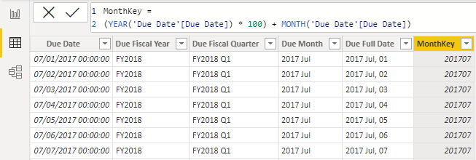

Understand row context
Power BI evaluates a calculated column’s formula for each row in the table, which is called row context. Row context just means “the current row.” For example, here’s the Due Fiscal Year calculated column:
DAX
Due Fiscal Year =
"FY"
& YEAR('Due Date'[Due Date])
+ IF(
MONTH('Due Date'[Due Date]) <= 6,
1
)
When Power BI runs this formula, 'Due Date'[Due Date] gives the value from the current row. If you’ve used Excel tables, this idea might feel familiar.
Row context only applies to the current table. If you need values from another table, you have two main options:
- If a relationship exists between the two tables, use the RELATED or RELATEDTABLE function. RELATED gets a value from the one-side of a relationship. RELATEDTABLE gets a table of values from the many-side.
- If there's no relationship, use the LOOKUPVALUE function.
Try to use RELATED when you can. It usually works faster than LOOKUPVALUE because of how Power BI stores and indexes data.
Here’s an example. This formula adds a Discount Amount column to the Sales table:
DAX
Discount Amount =
(
Sales[Order Quantity]
* RELATED('Product'[List Price])
) - Sales[Sales Amount]
Power BI calculates this formula for each row in the Sales table. It gets Order Quantity and Sales Amount from the current row. To get List Price from the Product table, it uses the RELATED function to find the right value for each sale.
Row context always applies when Power BI evaluates calculated column formulas. It also comes into play with iterator functions, which let you create more advanced summaries.

Understand implicit measures
Completed100 XP
- 6 minutes
Measures in Power BI models are either implicit or explicit. Implicit measures are automatic behaviors that let visuals summarize column data. Explicit measures, often called measures, are calculations you add to your model. This section explains how implicit measures work and how you can use them.

Identify implicit measures
As a data modeler, you control how a column summarizes by setting the Summarization property. You can choose Don't summarize or select a specific aggregation function. If you set a column to Don't summarize, the sigma symbol disappears in the Data pane.
In the Data pane, a column with the sigma symbol (∑) shows two facts:
- The column is numeric.
- Values are summarized when used in a visual that supports summarization.
The following image shows the Sales table with implicit measures, a calculated column, and one column that can't be summarized.
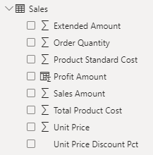
Notice in the example with the Sales table, if you add the Sales Amount field from the Sales table to a matrix visual that groups by fiscal year and month, Power BI summarizes the values implicitly. The Sum aggregation function is selected by default.
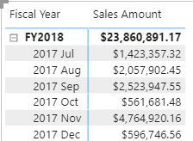
If you add the Unit Price field to the matrix visual, Power BI uses Average as the default summarization, because summing unit prices doesn’t make sense since they’re rates, not totals.
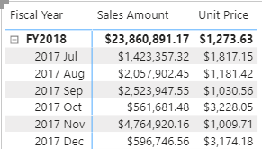
The default summarization is now set to Average (the modeler knows that it's inappropriate to sum unit price values together because they're rates, which are non-additive).
Implicit measures allow the report author to start with a default summarization technique and lets them modify it to suit their visual requirements. Numeric columns support the widest range of aggregation functions to choose from, including:
- Sum
- Average
- Minimum
- Maximum
- Count (Distinct)
- Count
- Standard deviation
- Variance
- Median

Summarize non-numeric columns
Non-numeric columns like text, dates, and boolean (true/false) values can also be summarized in your visuals. While the sigma symbol (∑) only appears next to numeric fields in the Data pane, these columns are still being aggregated.
- Text columns: First, Last, Count, Count (Distinct)
- Date columns: Earliest, Latest, Count, Count
This flexibility is useful when you want to answer questions such as:
- "How many unique products are there?" (Count distinct on a text column)
- "What was the earliest order date?" (Earliest on a date column)
- "How many orders were marked as complete?" (Count on a boolean column)
You can choose the aggregation option that best fits your analysis when you add a non-numeric field to your visual.

Considerations for implicit measures
Implicit measures are easy to use and flexible. They let report authors start with a default summarization and change it to fit their needs. Implicit measures let report authors quickly visualize data without needing to write calculations. As a data modeler, you spend less time creating explicit measures.
However, even if you set a default summarization, report authors can change it to something that might not make sense. For example, they could set Unit Price to Sum, which produces misleading results, as shown in the following image. The Unit Price values are large because they're the sum of unit prices instead of the static unit price per product.
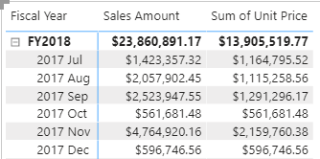
The biggest limitation is that implicit measures only work for simple scenarios. They can summarize column values using a single aggregation function, but they can’t handle more complex calculations. For example, if you need to calculate the ratio of each month’s sales amount over the yearly sales amount, you must create an explicit measure with a DAX formula.

Create explicit measures
Completed100 XP
- 7 minutes
You can add a measure to any table in your model by writing a DAX formula. A measure formula must return a single value. This section explains how to create explicit measures.
Measures don’t store values in the model. Instead, Power BI calculates them at query time to summarize model data. Measures can’t reference a table or column directly, so you must use a function to summarize the data.

Simple measures
A simple measure aggregates the values of a single column, just like an implicit measure.
For example, you can add a measure to the Sales table. In the Data pane, select the Sales table. On the Table Tools ribbon, select New measure.
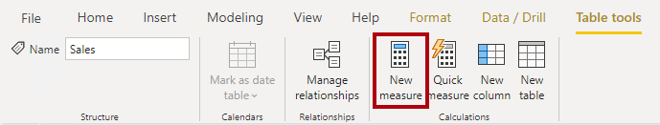
The following formula creates a measure called Revenue. This measure uses the SUM function to total the values in the Sales Amount column. If you add this measure to a table alongside the Sales Amount implicit measure, the results are the same.
DAX
Revenue =
SUM(Sales[Sales Amount])
Tip
Adding measures and hiding columns helps report authors use the explicit measures instead.
In the Measure tools contextual ribbon, you can format the measure, set data type, and change the home table. The home table refers to where the measure shows when looking at the data pane.
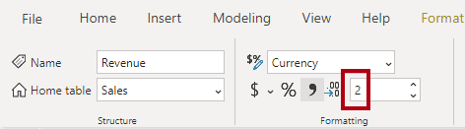
Tip
It's a good practice to set the formatting options right after you create a measure. This ensures your values look consistent in all report visuals.
Consider you might need a measure to calculate Profit as shown in the following code:
DAX
Profit =
SUM(Sales[Profit Amount])
In this example, the Profit Amount column is a calculated column. This approach isn’t optimal because you don’t need that column. In the next section, you see how to create a measure that calculates profit directly, which reduces model size and improves refresh times.
The following code creates two different measures to return Order Line Count and Order Count. The COUNT function counts non-BLANK values in a column. The DISTINCTCOUNT function counts unique values. Since an order can have multiple order lines, the Sales Order column has duplicates. Using DISTINCTCOUNT gives you the correct order count.
DAX
Order Line Count =
COUNT(Sales[SalesOrderLineKey])

Order Count =
DISTINCTCOUNT('Sales Order'[Sales Order])
You can also write the Order Line Count measure using COUNTROWS, which counts the number of rows in a table:
DAX
Order Line Count =
COUNTROWS(Sales)
All the measures referenced are considered simple measures because they aggregate a single column or single table.
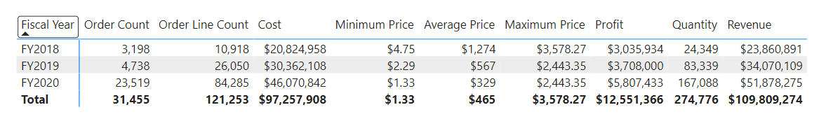

Create compound measures
A compound measure references one or more other measures. For example, you can redefine the Profit measure by referencing other measures. This measure can be used instead of the calculated column previously referenced.
DAX
Profit =
[Revenue] - [Cost]
This change to the model presents an important lesson: By removing the calculated column, you optimize the semantic model because it results in a decreased semantic model size and shorter data refresh times. The Profit Amount calculated column wasn't required after all because the Profit measure can directly produce the required result by using existing measures.
Note
Sometimes, it makes sense to define measures that depend on other measures. Always test changes carefully, because updates can affect all dependent measures.

Use Quick measures
Quick measures let you perform common calculations without writing DAX yourself. Power BI generates the DAX expression for you, which helps you learn and build your DAX skills.
For example, you can use a Quick measure to create a Profit Margin measure through the following steps:
- Select Quick measure in the Table tools ribbon.
- Choose Mathematical operations > Division.
- Add the Profit measure into Numerator and Revenue into Denominator.
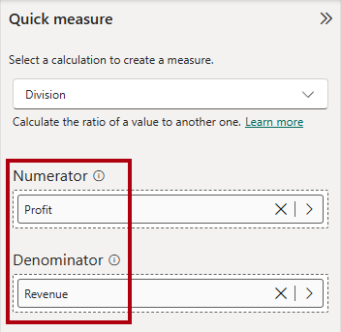
The new measure appears in the Data pane, and you can review its DAX formula:
DAX
Profit Margin =
DIVIDE([Profit], [Revenue])

Compare calculated columns and measures
Many DAX beginners find calculated columns and measures confusing at first. Both are created in the semantic model using DAX formulas, however, calculated columns and measures behave differently.
 | Calculated columns | Measures
Purpose | Adds a new column to a table | Defines how to summarize model data
Evaluation | Evaluated using row context at data refresh time | Evaluated using filter context at query time
Storage | Stores a value for each row in the table (Import mode) | Never stores values in the model
Use in visuals | Can filter, group, or summarize data (as implicit measures) | Designed specifically to summarize data
Performance impact | Can increase memory usage and model size | More efficient; better performance in large models
Ideal for | New fields for slicing or relationships | Dynamic calculations based on filters
Recognizing these differences helps you choose the right approach for your modeling and reporting needs.

Use iterator functions
Completed100 XP
- 7 minutes
Iterator functions evaluate an expression for each row in a table. They give you flexibility and control over how your model summarizes data.
Single-column summarization functions, such as SUM, COUNT, MIN, and MAX, have equivalent iterator functions with an "X" suffix, like SUMX, COUNTX, MINX, and MAXX. Specialized iterator functions also exist for filtering, ranking, and semi-additive calculations over time.
Every iterator function requires a table and an expression. The table can be a model table or any expression that returns a table. The expression must return a single value for each row.
Single-column summarization functions, like SUM, act as shorthand. Power BI internally converts SUM to SUMX. For example, both of the following measures return the same result and have the same performance:
DAX
Revenue = SUM(Sales[Sales Amount])
DAX
Revenue =
SUMX(
Sales,
Sales[Sales Amount]
)
Iterator functions evaluate the expression for each row in a table, using row context—meaning they process one row at a time to compute the final result. Then the table is evaluated in filter context. For example, if a report visual filters by fiscal year FY2020, the Sales table contains only sales rows from that year.
Important
Using iterator functions with large tables and complex expressions can slow performance. Functions like SEARCH and LOOKUPVALUE can be expensive. When possible, use RELATED for better performance.

Iterator functions for complex summarization
Iterator functions let you aggregate more than a single column. For example, a revenue measure can multiply order quantity, unit price, and a discount factor for each row, then sum the results.
DAX
Revenue =
SUMX(
Sales,
Sales[Order Quantity] * Sales[Unit Price] * (1 - Sales[Unit Price Discount Pct])
)
Iterator functions can also reference related tables. The discount measure can use the RELATED function to access the list price from the product table:
DAX
Discount =
SUMX(
Sales,
Sales[Order Quantity]
* (
RELATED('Product'[List Price]) - Sales[Unit Price]
)
)
The following image shows a table visual with the Month, Revenue, and Discount columns. Revenue and Discount are the measures previously created.
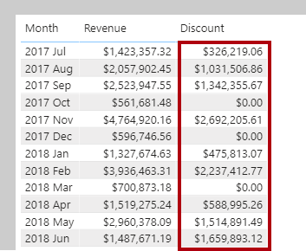

Iterator functions for higher grain summarization
Iterator functions can also summarize data at different levels of detail (grain). For example, you might want to calculate an average at the line item level or at the sales order level.
In this example, the Sales table contains one row for each line item in a sales order. Each row includes details such as the sales order number, product, quantity sold, unit price, and discount. Multiple rows can have the same sales order number, representing different items within the same order.
To calculate the average revenue per order line (line item), you can use the AVERAGEX function to iterate over each row in the Sales table. The formula calculates revenue for each line item, then averages the result across all line items in the current filter context:
DAX
Revenue Avg Order Line =
AVERAGEX(
Sales,
Sales[Order Quantity] * Sales[Unit Price] * (1 - Sales[Unit Price Discount Pct])
)
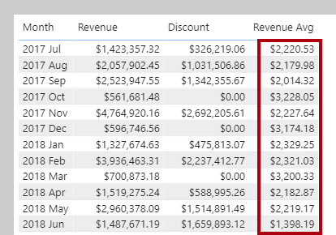
If you want to calculate the average revenue per sales order (rather than per line item), you can use the VALUES function to get a list of unique sales order numbers first. Then, AVERAGEX iterates over each sales order and averages the total revenue for each order:
DAX
Revenue Avg Order =
AVERAGEX(
VALUES('Sales Order'[Sales Order]),
[Revenue]
)
The VALUES function returns the unique sales orders based on the current filter context, so AVERAGEX iterates over each sales order for each month.
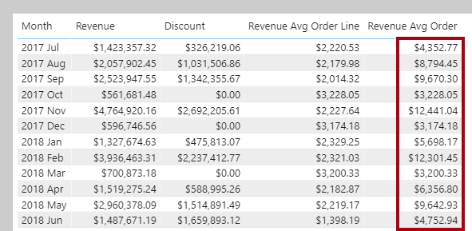

Ranking with iterator functions
The RANKX function calculates ranks by iterating over a table and evaluating an expression for each row.
Order direction can be ascending or descending. Ranking revenue usually uses descending order, so the highest value ranks first. Ranking something like complaints might use ascending order, so the lowest value ranks first. By default, RANKX uses descending order and skips ranks for ties.
For example, a product quantity rank measure can use RANKX and the ALL function to rank products by quantity:
DAX
Product Quantity Rank =
RANKX(
ALL('Product'[Product]),
[Quantity]
)
The ALL function removes filters, so RANKX ranks all products. In the following image, two products tie for tenth place, so the next product is ranked twelfth and rank 11 is skipped.
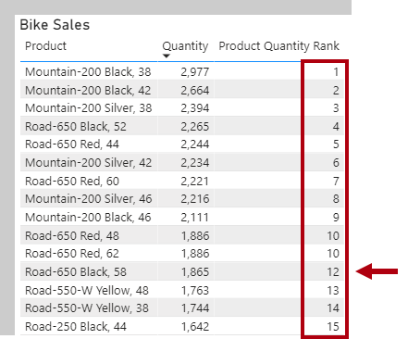
You can also use dense ranking, which assigns the next rank after a tie without skipping numbers. To use dense ranking, the measure can include the DENSE argument:
DAX
Product Quantity Rank =
RANKX(
ALL('Product'[Product]),
[Quantity],
,
,
DENSE
)
Now, after two products tie for tenth place, the next product is ranked eleventh and numbering continues sequentially without skipping rank 11.
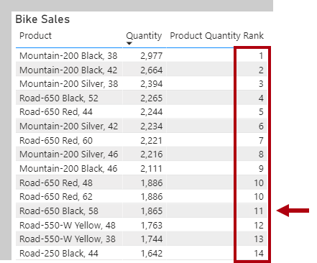
In this visual, the total row for the Product Quantity Rank measure shows one, because the total for all products is also ranked and there's only one value.
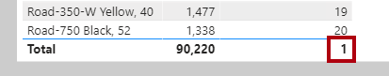
To avoid ranking the total, the measure can use the HASONEVALUE function to return BLANK unless a single product is filtered:
DAX
Product Quantity Rank =
IF(
HASONEVALUE('Product'[Product]),
RANKX(
ALL('Product'[Product]),
[Quantity],
,
,
DENSE
)
)
Now, the total for Product Quantity Rank is blank.
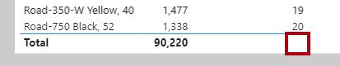
The HASONEVALUE function checks if the product column has a single value in filter context. This is true for each product group, but not for the total, which represents all products.
- An equivalent expression for HASONEVALUE() is COUNTROWS(VALUES(<columnName>)) = 1.
- This function is not supported for use in DirectQuery mode when used in calculated columns or row-level security (RLS) rules.

Iterator functions provide powerful ways to summarize, aggregate, and rank data in Power BI models. They support complex calculations and let you control the level of detail in your reports.
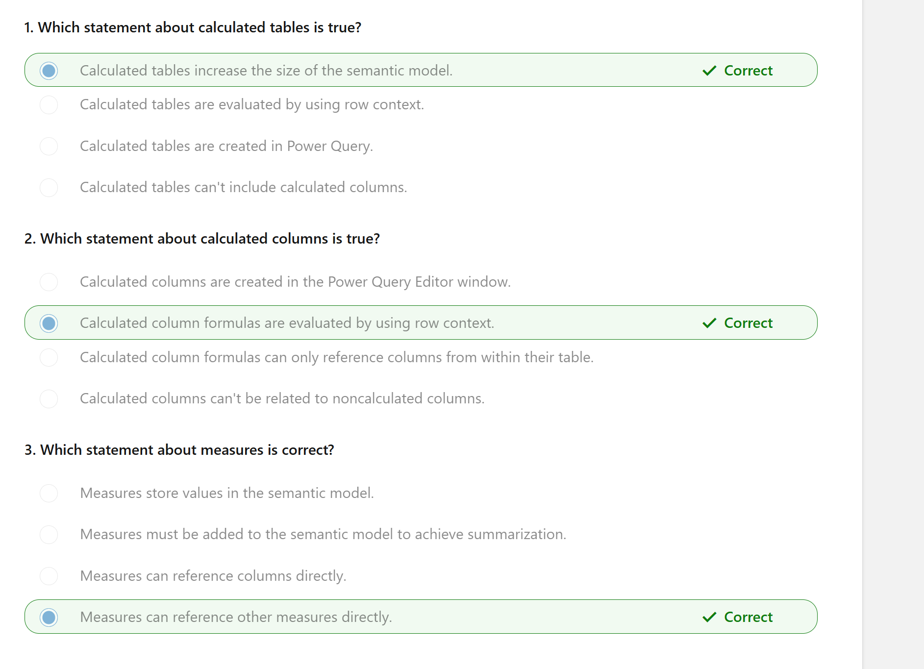
You learned the differences between calculated columns and measures, including when and how Power BI evaluates them and how they store data. Explicit measures are important because they allow you to create complex DAX formulas to achieve the precise calculations that your report visuals need.
You also learned how calculated columns are evaluated within row context, and iterator functions are available in measures for advanced row-by-row calculations.
Understanding how to create and use DAX calculatio

Design scalable semantic models
- Choose appropriate storage modes for your semantic model.
- Enable large semantic model storage format and incremental refresh.
- Create relationships between tables in a semantic model.
- Design dynamic elements to extend calculations in a semantic model.

Choose the best storage mode
Completed100 XP
- 6 minutes
When you design a scalable semantic model, selecting the appropriate storage mode is crucial. Depending on your data source, you have four options: Import, DirectQuery, Direct Lake, and Composite model. Each mode has its own advantages and considerations to ensure optimal performance and scalability.

Import Mode
Import involves importing and storing data within Power BI, offering the most flexibility and fastest performance. However, it requires periodic refreshes to keep the data current, meaning the data is only as up-to-date as the last refresh.
Guidance for Import models also applies to the other storage modes. You should always choose Import, if your model allows. The primary goal is to reduce how much data you bring into the semantic model and how many transformations are performed within Power BI. Optimization tips include:
- Connect to views instead of tables when working with relational databases.
- Only include necessary tables, rows, and columns.
- Consider partitioning and incremental refresh to avoid loading unnecessary data.
- Use appropriate data types, such as integer for ID columns instead of string.
- Ensure query folding, which reduces the work done within the Power BI engine.
Tip
Learn more about techniques to help reduce the data loaded into import models.

DirectQuery mode
DirectQuery allows you to query data directly from the source without storing it in Power BI, making it ideal for handling large volumes of data and near real-time data delivery. However, it has slower performance compared to Import Mode and offers limited modeling capabilities.
Optimization Tips:
- Avoid complex calculations at the source by simplifying Data Analysis Expressions (DAX).
- Apply dual storage mode for dimensions related to fact tables.
- Use the Assume Referential Integrity property on relationships.
- Avoid relationships on calculated and Unique Identifier columns.
Tip
See the documentation for more DirectQuery model guidance.

Direct Lake mode
Direct Lake allows querying data directly from a Microsoft Fabric lakehouse or warehouse without storing it in a semantic model, making it ideal for handling large volumes of data. This mode is optimized for quickly loading data into memory from Delta tables in Microsoft Fabric. While it offers the advantage of quick access to large data volumes, it requires the setup of a lakehouse or warehouse, and Delta tables might need to be tuned for optimal performance.
Optimization Tips:
- Configure Direct Lake to access ADLS (Azure Data Lake Storage) storage through shortcuts.
- Set up fallback behavior to DirectQuery for complex DAX queries.

Composite mode
Composite Mode mode can mix Import and DirectQuery modes, or integrate multiple DirectQuery data sources. This mode supports many-to-many relationships without the need for bridge tables. It offers the flexibility of querying and reporting capabilities by combining the benefits of both Import and DirectQuery modes. However, it requires periodic refreshes for Import mode tables and might have potential performance impacts when combining data from different sources.
Optimization Tips:
- Ensure the back-end source has sufficient resources.
- Minimize the number of literal values in source queries.
- Keep the cardinality of columns used in relationships low.
Tip
See the documentation for more Composite model guidance.
Configure incremental refresh and real-time data for Power BI semantic models - Power BI | Microsoft Learn
Advanced Incremental Refresh and Real-Time Data With the XMLA Endpoint in Power BI - Power BI | Microsoft Learn

Work with relationships
Completed100 XP
- 8 minutes
After choosing the model framework and transforming data, you need to create relationships to allow data to be filtered and aggregated based on data from another table. It’s common to create a star schema and enforce rules that filter dimension tables, allowing model relationships to efficiently apply those filters to fact tables.

Create a star schema
In our scenario, we imported a dimension table from .csv that needs to connect to the lakehouse. You can create relationships to shape a star schema after the imported table is transformed.
In a star schema, fact tables and dimension tables work together to organize and analyze data. The fact table stores the main data about business activities, like sales or events, while the dimension tables provide context and descriptive information about those activities.
For example, if you have a sales fact table, it might store data like the amount sold and the date of each sale. The dimension tables would then provide additional details, such as customer information, product details, and time periods. By linking the fact table to the dimension tables, you can easily filter, group, and analyze the data.
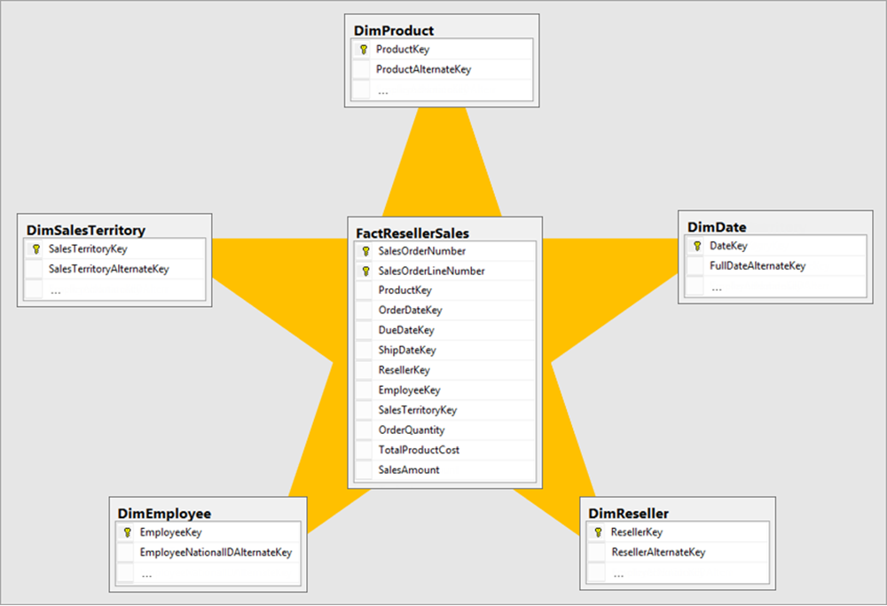

Create relationships
Creating relationships between fact and dimension tables is straightforward by identifying the related columns in each table and creating the relationship. In relational sources like databases or data warehouses, these columns are often known as keys. If key columns are absent, examine the tables to determine which columns to use for relationships.
Relationships come in different types:
- One-to-Many is the most common type, where one record in a table relates to multiple records in another. Typically, one-to-many is from a dimension table with one unique value to a fact table with many rows related to the one value.
- Many-to-One is essentially the same as One-to-Many, depending on which way the filter is configured between tables.
- One-to-One is less common as both tables have unique data. Consider if you need two tables or can combine them into a single table.
- Many-to-Many is less common but necessary for complex data. It allows multiple records in one table to relate to multiple records in another.
For many-to-many relationships, you might need to use a bridge table. A bridge table helps manage these relationships by linking the tables through intermediary keys. Composite models also assist with many-to-many relationships by allowing you to combine data from different sources.

Filter direction
When you create a relationship, you configure which direction the data is filtered from one table to another. In a star schema, the direction typically goes from the dimension table to the fact table, allowing the dimension table to filter the fact table's results.
Bi-directional filters are also possible and sometimes used in one-to-one or many-to-many relationships. Before using a bi-directional filter, ensure your data and relationships are correctly configured. Be cautious, as bi-directional filters can negatively affect model query performance and potentially confuse report users.
Referential integrity ensures that relationships between tables remain consistent. It means that every value in a foreign key column must have a corresponding value in the primary key column of the related table. This feature also improves query performance when using INNER joins as opposed to LEFT OUTER joins.
Understanding filter direction and referential integrity is crucial for accurate data modeling. Filters only propagate if the relationship path is intact and follows the defined direction. These configurations ensure data consistency and integrity across your model.

Inactive relationships
Relationships can be disabled and have their filter context modified by DAX functions. Sometimes, you need more than one relationship between tables, but only one can be active at a time between two tables. In such cases, use the USERELATIONSHIP function in DAX to reference inactive relationships to get the same filtering behavior. Here’s an example:
DAX
CALCULATE(
SUM(Sales[Amount]),
USERELATIONSHIP(Sales[Date], Calendar[Date])
)
Using DAX functions for relationships is valuable because they allow you to create dynamic and flexible calculations that can adapt to different data scenarios. This flexibility enables you to handle complex data models and perform advanced analytics that would be difficult to achieve with static relationships alone.

Use disconnected tables
It's unusual that a model table isn't related to another model table. Such a table in a valid model design is described as a disconnected table. A disconnected table isn't intended to propagate filters to other model tables. Instead, it accepts "user input" (perhaps with a slicer visual), allowing model calculations to use the input value in a meaningful way. For example, consider a disconnected table with a range of currency exchange rate values. When filtering by a single rate value, a measure expression can use that value to convert sales values.
The Power BI Desktop what-if parameter is a feature that creates a disconnected table. For more information, see Create and use a What if parameter to visualize variables in Power BI Desktop.

